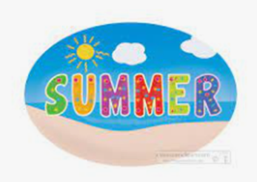
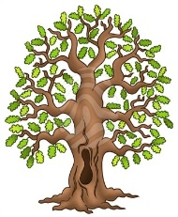
Half-termly Curriculum Statement
We’re back after the residential and we’ve got a lot to do before move-up and the end of term.
Our topic for this half term is called Healthy Bodies and we are focusing on Animals including Humans – what happens to our bodies as we grow older and what helps to keep those bodies healthy. Last week, I sent out a letter about the Relationship and Sex Education session I will be doing with the children on Thursday 16th June – as with last week’s newsletter, the letter stated that the meeting for this is today (13th June 2022) for those parents who would like to attend. You are all very welcome.
Our quality text this half term continues to be Darwin’s Dragons by Lesley Galvin. Year 6 writing is being moderated for SATS by Norfolk County Council later this week and I look forward to sharing some of the children’s work with the impartial moderators – it is usually a very positive experience. Final SATS results come out at the beginning of July when Mrs Owner and I share them with each individual child privately before they bring home a letter.

Here is our timetable for the second part of the Summer Term.
PE continues to be on Mondays (Athletics) and Tuesdays (Swimming). Please continue to send in your children wearing PE kit on those days.
The homework grid will be coming home in your child’s homework book; some parts are compulsory and others are optional. We are looking at healthy eating and healthy meals, so your child might even choose to cook you a balanced meal from the options.
Kind regards,
Team Oak – Miss Rickards, Miss Chalk, Mrs Stubbings and Mrs Hovell
