Elm class – Spring 1
Curriculum statement
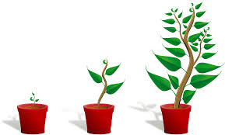
Our topic this half term is ‘In the Forest’ We will be looking at what plants, flowers and trees need to grow. We will be growing our own seeds and bulbs, and investigating the best environments that they will need to flourish. We will be naming parts of a flower and of a tree.
In computing we will be learning how to word process and create a powerpoint. We shall be reminding ourselves how to keep safe online.
In art we will be creating mosaics.
In DT we will be looking at where our food comes from and honing our culinary skills.
In geography we will be looking at different types of weather from around the world. We shall be keeping a weather chart and looking at what could happen to our world due to global warming
Our quality texts are Jim and the Beanstalk; we shall use this book to put a spin on a fairy story we already know. A seed is sleeping will be our non-fiction text and we shall use this to write reports. We shall also be reading and composing our own Haiku poems.
Spellings will continue to be on a Monday and Rainbow Club and 99 Club on a Thursday.
PE will continue to be on a Monday with Miss Reidie and a Tuesday with Mrs Hovell.
Please do not hesitate to contact me via primary@iceni.attrust.org.uk
Thank you all for your ongoing support.
Best wishes
Mrs Cooper

