Elm Homework grid Autumn 2 2020 Topic: Scrapheap Challenge
Reading  Read daily with either your individual reading book or one from home. Make sure you have your reading record book signed daily so that you can be entered in the Reading Raffle.  Mastery: Write a book review about your favourite book that you have read. | Spelling  Practise the spellings you are given every Monday.  Remember to concentrate on your handwriting too.  Mastery: Don’t forget to write sentences using your spellings. | Mathletics/TTRockstars  Log on and practise your Mathletics and TTRockstars.  Remember to ask if you’ve forgotten your username and password.  practise your timetables:  Year 2: x2, x3, x5, x10  Year 3: x4, x8, x50, x100
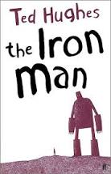  Topic  The Iron Man visits lots of different locations – draw a map to show where he goes. | DT  Use craft materials to make your own robot model... or could you make a life-sized robot? | Maths mastery  The Iron Man is taller than a house? How tall is this? What units of measurement might be sensible for measuring things taller than a house? | Science  Gather together a number of ‘everyday materials’. Find out whether they are natural or man-made. Find out what material they are made from. Create a chart showing your results.  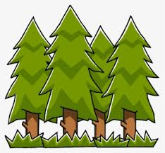  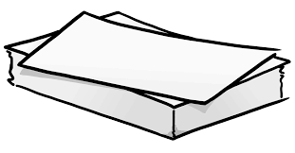  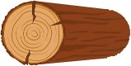
Art  Draw a picture of the space-bat-angel-dragon that lands in Australia.  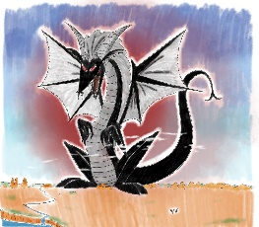 | Writing  Create your own version of ‘The Iron Man’ and write a detailed character description. Ideas to include: What is their name? What material are they made from? How tall are they? What do they like to eat? What are their strengths and weaknesses? How could you describe their… Face - eyes, nose, mouth and ears. Body - arms, legs, hands, feet, clothes, etc. | RHSE  The Iron Man helps the world to become more peaceful. Think of ways that we can help to encourage people and countries to live more peacefully alongside each other.  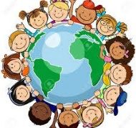
The homework grid should be completed this half term. The compulsory tasks ( ) must be completed each week.
There are additional optional tasks that complement what we have been learning in the classroom.
Please hand your homework in on Wednesday 16th December 2020

