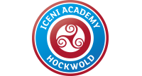

Newsletter February 2020

Dear Parents/Carers

Your children have done amazingly well with their attendance this half term!

So well in fact that we have been ABOVE our 97% target for the last five weeks. This has brought up our overall attendance to 96.12% - so close to where we need to be!

We also have 15 children who are currently at 100% attendance so very well done to them. Thank you for all of your support and hopefully we can do even better next half term.
As you will recall, we asked parents to complete a survey about our academy earlier on this academic year. We received 34 replies. Overall, they were very positive, although one parent is not happy with our academy. I would be very grateful if you would make an appointment to come and see me to explain why you are unhappy, so we can put it right for you. I am pleased that all 34 replies stated that their child is happy to attend school and feels safe in school, both of which are most important. All agreed that their child does well at this school too. There was one negative response about the school dealing with bullying effectively. I feel it is important to remind everyone, that bullying is only classed as such when a child repeatedly picks on another child, over a period of time. Falling out once or twice is not bullying.
One parent feels that we do not make parents aware of what their child is learning throughout the year. We currently provide a curriculum statement at the beginning of each half term, update the class website pages and send termly academic updates home. If that parent could give me some ideas of what else to do, please let me know. We did have a negative response in answer to children taking part in extra-curricular clubs, again, please do come and see me. We always like feedback to improve the academy as much as we can so thank you to those of you who completed this. Acorn class parents have also been completing a survey, details of that to come next time, but thank you in advance!
Rev Ken has been a Governor and friend of our academy for many years, with his inspiring sermons in church and his humor during events held in school. Now, he has decided to move on, to Cyprus no less! We wish him, his family best wishes, and a life full of adventure. We will all miss him and hope that he stays in touch!
Tom Taylor, our site supervisor has also decided to leave, due to personal reasons. We wish Mr. Taylor lots of luck as he moves into the building trade.
We are also saying goodbye and thank you to Miss Smith who has been covering Miss Reidie’s maternity leave. We wish her all the luck in her next venture of becoming a Mum herself!
We welcome Sharron Smith to our team. Mrs. Smith is an experienced teaching assistant and will be working mostly in Acorn class. I know that we will all make her feel welcome.
Have a lovely week off everyone, and thank you for your continuous support.

Mrs. E. Owner
Principal

FoSHA News…
Thank you to everyone that came to support our recent family race night at the village club – we made a profit of £312 for the school.
For those of you who are unsure what FoSHA are about and what we do, we are a registered charity made up of staff and volunteers that raise money for Iceni Primary by holding various events throughout the school year. The money we raise goes straight back into our academy and allows us to subsidise school trips, buy equipment and books for the children and make sure their school life is as enriched as possible.
We are always looking for new volunteers to join our committee – the more people we have the more ideas we have and more we can do for the children.
If you would like to join us or would like to know more about what would be required of you as a committee member, please come and see Ms Burdett at reception and pick up a volunteer form.

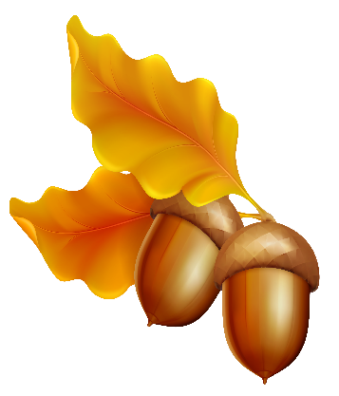Acorn

Another busy half term in Acorn class - we have been learning all about Light and Dark.
We had a visit from Plop the Owl, made and acted out our own story paths with shadow puppets and have been learning all about why we have night and day.

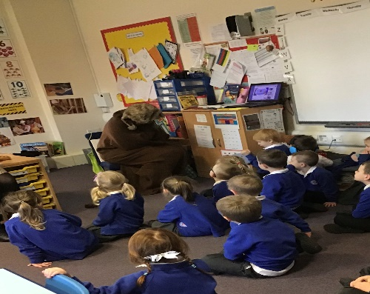

We have also been learning about the different kinds of birds that we can see in our gardens and thinking about how we can help them in the winter. We decided to make some bird cakes to put out in our own gardens - I am sure the birds will enjoy eating them!
Have a lovely half term!
Mrs Harris

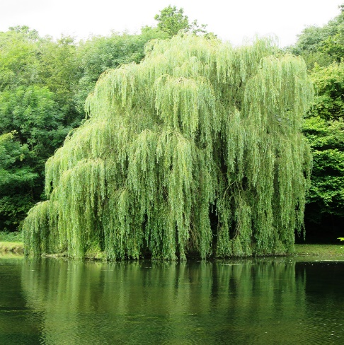 Willow

Well, where in the world have we been this half term? We have travelled to, and learnt the names of, the continents of the world. We have learnt about their countries, people, weather and animals. In English we have visited and learnt about the rainforest through sharing a powerful story about all the creatures in the Kapok Tree and how they must convince Serhan not to cut the tree down. We have also shared and learnt about how non-fiction books are different from our story books. We have found out about The Northern Lights, had a trip to The Colosseum and visited a volcano! A big thank you to those of you who were able to make it to the Reading Café. It was great fun with lots of lovely learning going on throughout the afternoon - we hope you enjoyed it as much as we did!
Our maths learning continues to go from strength to strength: this half term we have solved additions, subtractions, and looked at place value, 2d shapes and fractions. We have trialled Times Tables Rockstars which everyone has enjoyed.
In RHSE we have learnt to keep ourselves safe at home, at school and whilst we are out and about. We have learnt who we ask for help from as well as make our own choices to keep ourselves safe. We’ve learnt about being safe on the inside too by taking part in our Mental Health Wellbeing Day - we learnt how to eat healthily, relax, be calm and know that sometimes it’s ok to be sad and what to do when we need a bit of extra support.
We have learnt to make levers and hinges – put to very good use when we made an animal with moving parts.
We have been very fortunate to learn more about a school in a different part of the world as we have been sending and receiving emails from a school in Dubai. We have been very excited to read the responses to our questions.
We also are following the travels of a volunteer Lynne. “Where in the world is Lynne?” has become a daily feature as we follow her cruising around New Zealand and onto Australia.
I would like to say thank you, to you, for supporting your child as they have taken on the challenge of homework. They have all enjoyed sharing what they have accomplished.
Have a lovely February half term.
See you all again on Monday 24th February when our new topic will be ‘In the Forest’.
Mrs Cooper and Willow Class Team

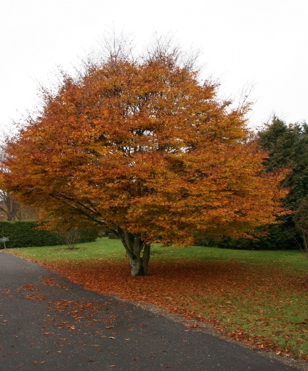 Beech

The children in Beech Class have written about one of their favourite things they learned about this half term with our topic of Ancient Egypt below. Have a wonderful half term break. We start a new topic about Location, Location, Location next half term. From Mrs Slade and Mrs Hawes.

English
Oscar – We found out that no-one knows how King Tut, also known as Tutankhamen, died. We are now writing Egyptian style fairy-tales.
Phoebe - We were finding out about how Tutankhamen died. At the start, nearly everybody thought that he was murdered, but then nearly everyone thought he had a wound or was sick, but really no-one knows.
Alex – we have been learning about Ancient Egypt and read an e-book.
Maxwell – we have been doing a fairy tale of Egypt. First, we did a normal fairy tale but we turned it into an Egyptian one.
George – We have been learning about the Egyptians and then we put on the board about how did Tutankhamen die? Then after that, we tried writing our own fairy tale and we listened to the Egyptian Cinderella.
Jake – We have been doing ‘Was Tutankhamen Killed?’ No one knows if it is a true mystery. We suspected his advisors Ay and Horemheb.
Cullen – In English, we were doing the Egyptian Cinderella. In part of the story, she was named Rhodopis. Rhodopis dances with animals and she got rose and gold slippers. Then her slipper is stolen by a hawk.
Maths
Henry – For this half term, we have been learning about fractions, subtractions and adding.
We did fractions – so fractions is something like this: 1/3 that’s one third.
Subtraction is basically backwards adding.
Adding is this 1+1=2 that is one plus one equals two.
Noah – This half term in maths we did fractions and addition, plus subtraction. My favourite was addition because it is really easy. You just add the numbers. I got three whole pages and I got them all right.
Olivia – We have been doing this half term fractions and it’s really fun and really easy. We did pictures with the fractions. We have been talking about denominators and the one that goes on the top.
Roxy – What we’ve been doing this half term in maths. We have been doing adding, subtracting and fractions. We have been doing column method and we have also been doing a mental method where we tried to work out the sum without using column.
Science
Mason – we were doing different types of teeth and food chains.
Max – In science, we learnt about teeth – incisors, molars and canines.
Amelia – We learned science and we looked at our teeth. We learned what our different teeth are called.
Shannon – In science, we were learning about teeth and how to draw our own teeth and how to look after them. We learnt there are three different kinds – incisors, molars and canines.
Delilah – In science, we did teeth and drew our own teeth. We learnt three different kinds – incisors, molars and canines.
Teegan – In science, we had a piece of paper and we did what our teeth are like. We drew all of our teeth. We labelled them with the names. One was called molars, some are sharp, some are smooth. We have three different types of teeth.
History
Dylan – What we are doing is learning about the Egyptians. So far, in the Egyptians we know lots of things like the Egyptians used to believe they would go into the afterlife when they died.
Blake – we had some stories and facts about Tutankhamen and we have learnt some facts. We made cartouches and pyramids. It was fun.

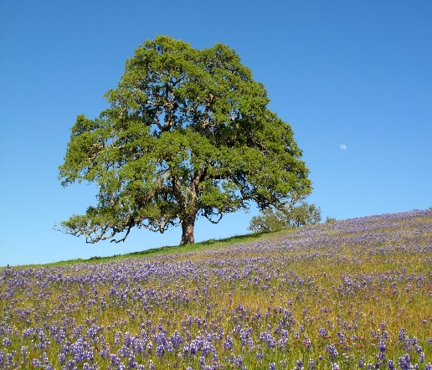 Oak

Our topic this term has been Location, Location, Location. Unfortunately, we couldn’t fund going to Spain or Brazil! Instead, we went for a walk around Hockwold: we saw the Stag’s Head Stone near Boundary Close and we also went to the Little Ouse [the river]. There, we found a place to rest whilst we sketched a part of what we could see: the horizon, birds, types of trees and the flow of the river.

We went to RSPB Lakenheath where we learned about how to classify animals and how to compare animals that look similar. We are going to continue with our Location topic after half term and will be travelling to Hunstanton beach to do more classifying of sea creatures plus looking at the history and geography of the area on 25th March.

In Art we have been making and painting dragon eyes out of clay and paint; they were very delicate and detailed. We also did Pablo Picasso-inspired portraits so we got into partners – it was great fun. In Music we have been composing ‘sounds of the rainforest’ and by the end of term we will have created a multi-layered composition. Such fun! 🙂

By Bow and Erin

Don’t forget: we have second hand uniform (including PE kit and coats) for sale in the library. Thank you to everyone that has kindly donated items.

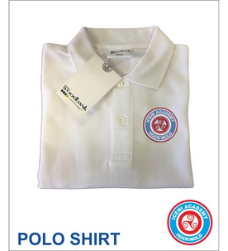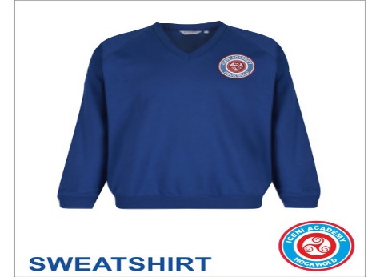

We are so proud of all our children and how they have immersed themselves in the BEAR Project. Wow - children are so committed to it and to talking about their books when they have finished reading them. We've even had instances of children recommending books to each other without prompting. Congratulations to Izzy A, Max and Roxanne who have already received their bears. Amazing!
Miss Rickards.

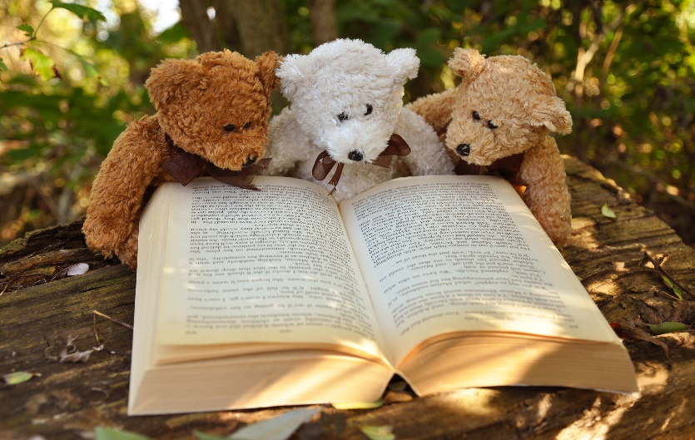

World Book Day
A quick heads up for World Book Day on Thursday 5th March: we will be dressing as our favourite BEAR Project book characters. In addition, we will be running a competition about being ‘caught in the act’ reading somewhere peculiar (but safe). In the past, children have submitted photos of themselves reading in trees, under the stairs, in a den they’ve made themselves and in the fruit and veg aisle of the local supermarket! Please do start taking photos of reading in imaginative places and sending them to primary@iceni.attrust.org.uk
We will judge the competition on World Book Day.

